1.17 – If the company wants to use an option contract to hedge its risk, it should buy a put option that gives it the right to sell the foreign currency at the strike. If the foreign currency depreciates in value (buys fewer units of the home currency), the company can sell it at the higher strike price (exchange rate) and therefore be hedged.

1.18 – The company can hedge its risk by either a forward contract or an option. To use the forward contract, the company could either (a) enter into a long position whereby it buys 1 million Canadian dollars in the future for a set amount of US dollars, or (b) enter into a short position whereby it sells US dollars and agrees to buy 1 million Canadian dollars. In either scenario, the company is accepting Canadian dollars in exchange for US dollars at a fixed exchange rate.

To use an option, the company should use a call option that gives it the right to buy 1 million Canadian dollars at a fixed rate. This protects the company from a depreciating dollar – if the dollar depreciates, then the Canadian dollar becomes more expensive, and the call option would give the company the right to buy Canadian dollars at the lower price.

1.22 – This is a protective put on the forward contract. The put will protect from the value of the asset declining because it gives the holder the right to sell the asset at the strike. If the price of the asset falls below the strike, then the option will be exercised and the payment to the holder will equal the difference between the strike and the value of the asset. If the price of the asset is above the strike, the option will not be exercised and will expire worthless. The cost of the option can be viewed as the cost of insurance, protecting against a loss in value due to a decrease in the value of the asset.

1.23 – This structure is a collar, which is a combination of a long put and a short call. When the exchange rate is above 169, the ICON pays $1,000 (like a $1,000 bond). When the exchange rate is between 84.5 and 169, the payoff is:

$1000-1000\left[\left(\frac{169}{S_{T}}\right)-1\right]=1000-\left(\frac{169000}{S_{t}}\right)+1000=2000-\frac{169000}{S_{T}}$

When the exchange rate is below 84.5, the payoff is 0. Fundamentally, this can be reconstructed by buying a put option with a strike of 84.5 (if the exchange rate drops below 84.5, a payoff is made which limits/offsets further losses in value) while also selling a call option with a strike of 169 (if the exchange rate climbs above 169, the short call loses value and any further price appreciation is lost). The holder of the ICON loses upside potential when the exchange rate is in excess of 169 because the payment is limited to $1,000 but also has limited downside exposure because the loss is limited to 0 if the exchange rate is less than 84.5.

1.39 – The treasurer can buy a put with a strike of 1.52 and sell a call with a strike of 1.58. If the exchange rate drops below 1.52, further decreases are offset by the option to sell the currency at the higher exchange rate of 1.52; similarly, if the exchange rate increases above 1.58, further increases are offset by the obligation to sell the currency at a rate of 1.58. This therefore locks in the range of 1.52 to 1.58.

1.40 – ImportCo needs to pay £10MM in 3 months, so in 3 months it needs to buy pounds with dollars. The risk is that the dollar depreciates and it costs more to buy £10MM. To hedge its risk, it could purchase a call option at a strike of 1.57, which gives it the option to buy £10MM. If the exchange rate increases above 1.57, then ImportCo would exercise its option to purchase pounds at the lower cost. For example, if the exchange rate increases to 1.60, then £10MM would otherwise cost $16MM. The option would allow ImportCo to instead pay $15.7MM for the £10MM. Below is a screengrab from DerivaGem to price this option. The cost is $40,383, or the price of the option times £10MM:

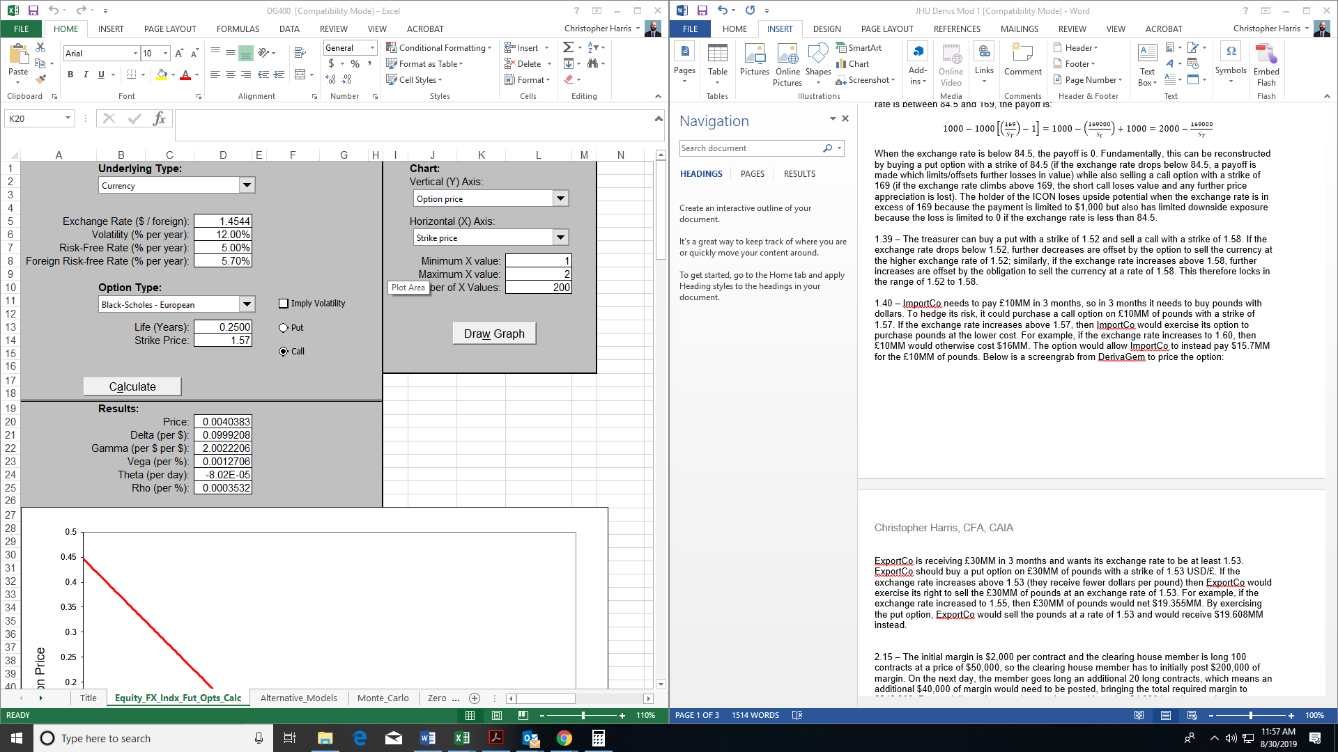

ExportCo is receiving £30MM in 3 months and wants to exchange it into dollars at a rate of at least 1.53. ExportCo should buy a put option with a strike of 1.53 USD/£, which gives them the right to sell £30MM. If the exchange rate decreases below 1.53 (they receive fewer dollars per pound) then ExportCo would exercise its right to sell the £30MM at an exchange rate of 1.53. For example, if the exchange rate decreased to 1.50, then £30MM would net $45MM. By exercising the put option, ExportCo would sell the pounds at a rate of 1.53 and would receive $45.9MM instead. Below is a screenshot from DerivaGem to price this option. The cost is $2,594,229, or the price of the option times £30MM. This option is more expensive because it is currently in-the-money:

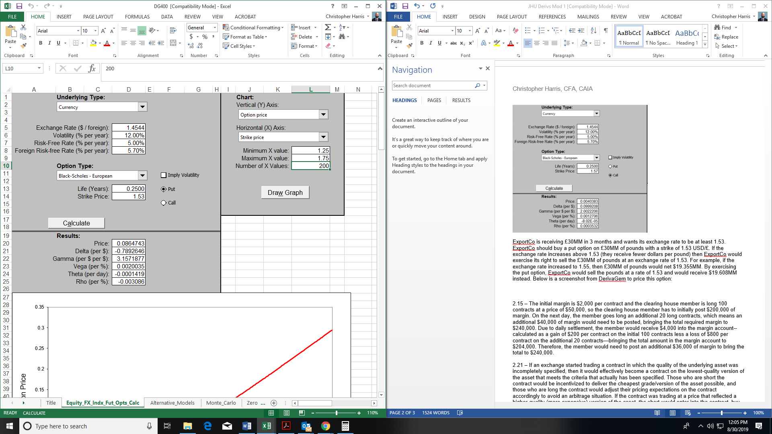

2.15 – The initial margin is $2,000 per contract and the clearing house member is long 100 contracts at a price of $50,000, so the clearing house member has to initially post $200,000 of margin. On the next day, the member goes long an additional 20 long contracts, which means an additional $40,000 of margin would need to be posted, bringing the total required margin to $240,000. Due to daily settlement, the member would receive $4,000 into the margin account--calculated as a gain of $200 per contract on the initial 100 contracts less a loss of $800 per contract on the additional 20 contracts—bringing the total amount in the margin account to $204,000. Therefore, the member would need to post an additional $36,000 of margin to bring the total to $240,000.

2.21 – If an exchange started trading a contract in which the quality of the underlying asset was incompletely specified, then it would effectively become a contract on the lowest-quality version of the asset that meets the criteria that actually has been specified. Those who are short the contract would be incentivized to deliver the cheapest grade/version of the asset possible, and those who are long the contract would adjust their pricing expectations on the contract accordingly to avoid an arbitrage situation. If the contract was trading at a price that reflected a higher-quality (more expensive) version of the asset, the short would enter into the contract, buy the lower-grade asset in the spot market (factoring in storage costs), and then deliver into the contract at a higher price than they paid. This would be a form of a cash-and-carry arbitrage.

2.22 – Open interest is the total number of positions outstanding on a futures contract (both long and short). Open interest increases when a brand new contract is written (meaning new to both parties and not closing out an existing position). If a contract is written that closes an existing position for one counterparty but opens a new position for the other counterparty then open interest remains unchanged – the closing of one position is offset by the opening of another, and this in essence just represents the transfer of a contract from one counterparty to the other. Open interest decreases by one if both counterparties to a transaction are closing out their position.

2.28 – Open interest is the total number of positions outstanding (not closed – meaning long and short) in a futures contract. It effectively represents how many positions there are in the market that have not been closed out yet. Open interest usually declines during the month preceding the delivery as traders close out positions to avoid actually taking physical delivery. Traders may also close out positions to lock in profits/mitigate losses. Additionally, some traders will start closing out to roll positions forward.

The open interest will drop to 1400. The 2000 buyers consist of (a) 1400 shorts being closed, which drops the number of open short positions to 600, and (b) 600 new long positions, which increases the number of long positions to 2600. The 2000 sellers consist of (a) 1200 long positions being closed, which drops the number of open long positions from 2600 to 1400, and (b) 800 new shorts being opened, which increases the number of open shorts from 600 to 1400. In other words, of the 2000 trades in the day, 1200 shorts and longs can be matched up/paired off to reduce the number of open contracts; 600 new contracts are written; and 200 existing shorts are transferred from traders closing out positions to traders opening new positions, which does not increase open interest.

This results in open interest of 1400, which consists of (a) the 800 long contracts that weren’t matched up and paired off plus 600 new long contracts and (b) the 600 short contracts that weren’t closed out plus 600 new shorts plus 200 existing short contract that were effectively “transferred”.

2.31 – In this particular instance, you could buy the June contract at $80 and sell the December contract at $86. In June, you would borrow $80 at 5% and take delivery of the oil. The oil would be stored at no cost until December, at which point the short would expire and you would make delivery of the oil at the futures price of $86. These proceeds would be used to repay the loan, which would have a total accrued value of $82. This would leave a profit of $4.